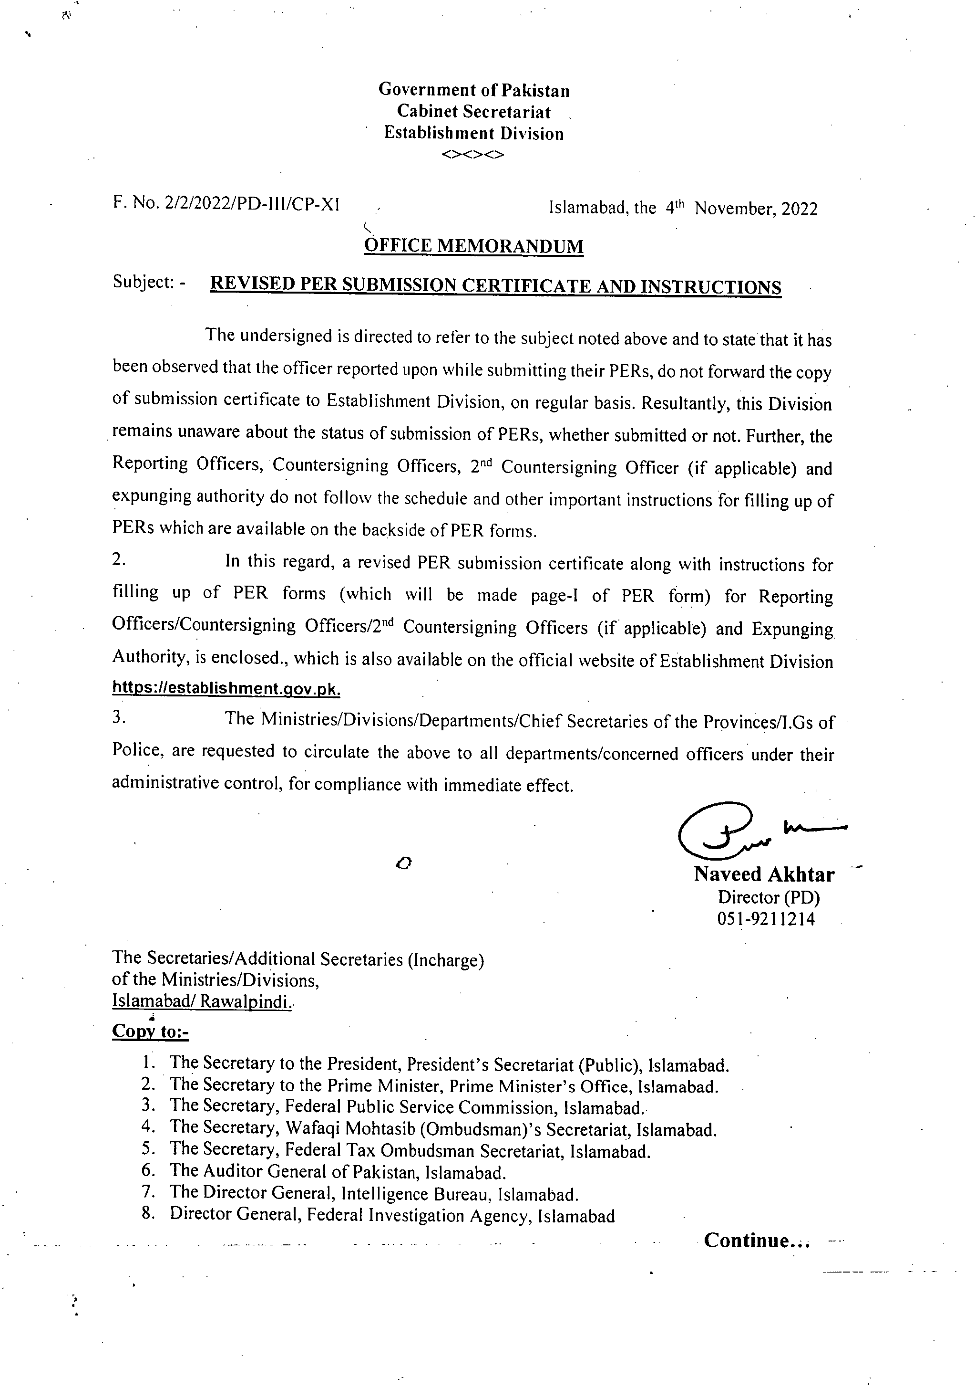
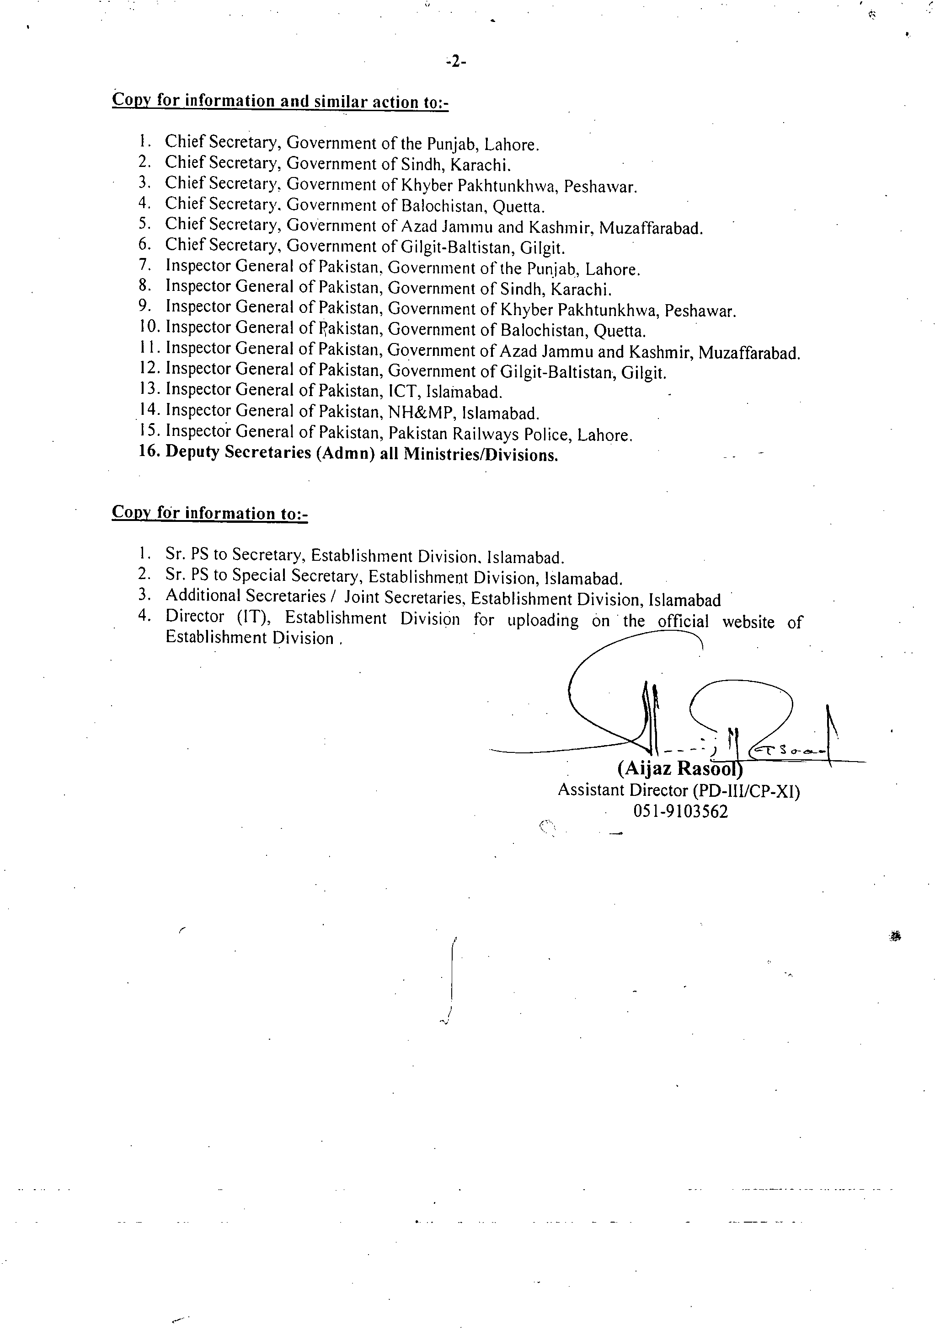
PER SUBMISSION CERTIFICATE FROM OFFICER REPORTED UPON

Certified that I ___________________________________________________________
(Name of Officer)
_______________________________________ have on ______________submitted my
(Designation/BS/Group/Service) (Date)

Performance Evaluation Report for the period from ______________________________

To be initiated by ________________________________________________________
(Name/Designation of Reporting Officer)

To be countersigned by ____________________________________________________
(Name/Designation of Countersigning Officer

Signatures ________________

To,

(Serving Administration
/Ministry/ Department) _________
__________________
__________________
CC :
Director (PD),
Establishment Division

Instructions for Officer Reported Upon.

Extract of Para-6.7 of AGPE-2004 and Guideline for filling up of PER

  - PER along with Submission Certificate should be prepared annually at the close of each calendar year which is required to be dispatched to the Officer Incharge entrusted with the maintenance of his/her C.R dossier and copy of above certificate must also be forwarded to Establishment Division.
  - Part I and II of PER are required to be filled in duplicate/typed and signed by the officer reported upon.
IMPORTANCE OF PER IN CAREER PLANNING

The Performance Evaluation Report (PER) is an important document which should be completed by the stakeholders with utmost care in stipulated time period. It is required during the appointments as well as promotions have to be made.

Instructions for Officer Reported Upon/Reporting Officer/Countersigning Officer/Second Countersigning Officer (if applicable) / Expunging Authority

Officer Report Upon PER along with Submission Certificate should be prepared annually at the close of each calendar year which is required to be dispatched to the Officer Incharge entrusted with the maintenance of his/her C.R dossier and copy of above certificate must also be forwarded to Establishment Division.Concerned Administration. After initiation/submission of above certificate along with set of PERs, the concerned administration will on the same date forward the same to Reporting Officer. This shall enable to ensure follow-up and prompt retrieval of PERs from the Reporting/Countersigning Officers.R.O/CO/2nd C.O (if applicable)After receiving PERs from administration, R.O will complete the same within two weeks. After that C.O will countersign in the next two weeks and 2nd Countersigned (if applicable) in subsequent two weeks and must follow the guidelines mentioned in backside of PER form.Expunging Authority in case of adverse remarksThe role of expunging authority is as a judge who examine/decide the representation of the officer reported upon and comments of the C.O on the representation under paras-3.40,3.41 and instructions provided on the backside of PER form of AGPE-2004.The concerned administration will get the PER completed and must be forward to Establishment Division under para-2.37 & 2.38 of AGPE-2004 as per given schedule
Officers of Grade 21 and 20 ..............................31st January

Officers of Grade 19 ..........................................28th February

Officers of Grade 18 and 17 ..............................31st March

Failing which disciplinary proceedings will be initiated under para-2.35 (iii) & (iv) of AGPE-2004 which is as under:-

(iii)The President is pleased to direct that the reporting officers concerned will be held responsible for ensuring that the reports of the officers working under them are written in time and sent to the Establishment Division/Administrative Ministry concerned when due with the least delay.

(iv)In case the President received further complaints in this regard, serious notice will be taken thereof and defaulting officers will be liable to disciplinary action.

-1-

1
FOR OFFICERS IN BPS 21 RESTRICTED


GOVERNMENT OF PAKISTAN


Ministry /Division/ Service/Group
Department/Office


PERFORMANCE EVALUATION REPORT


FOR THE PERIOD 20 TO 20

PART I

(TO BE FILLED IN BY THE OFFICER REPORTED UPON)


- Name (in block letters)

- Personnel number

- Date of birth

4. Date of entry in service

5. Post held during the period (with BPS)

- Academic qualifications

- Knowledge of languages (Please indicate proficiency in speaking (S), reading (R) and writing (W)


2

- Participation in conference, seminars, meetings during the period reported
upon.

Title   | Country   | Duration with date  

9. Period served

(i) In present post (ii) Under the reporting officer


PART II
(TO BE FILLED IN BY THE OFFICER REPORTED UPON)


- Job description


3

- Significant achievements during the evaluation period


PART III

(REPORTING OFFICER’S EVALUATION)


- Comments on the officer's performance on the job


4

- Assessment of officer's


i) Strategicvision (Ability to transform the organization in view
 of changing environment)

ii) Integrity (Morality, uprightness, honesty and commitment
 to national interests)

iii) Ability to supervise, guide, and motivate subordinates


iv) Area of professional expertise with recommendations for future posting


5

- Pen picture


4. Overall grading




Name Signature


Designation Date


6

