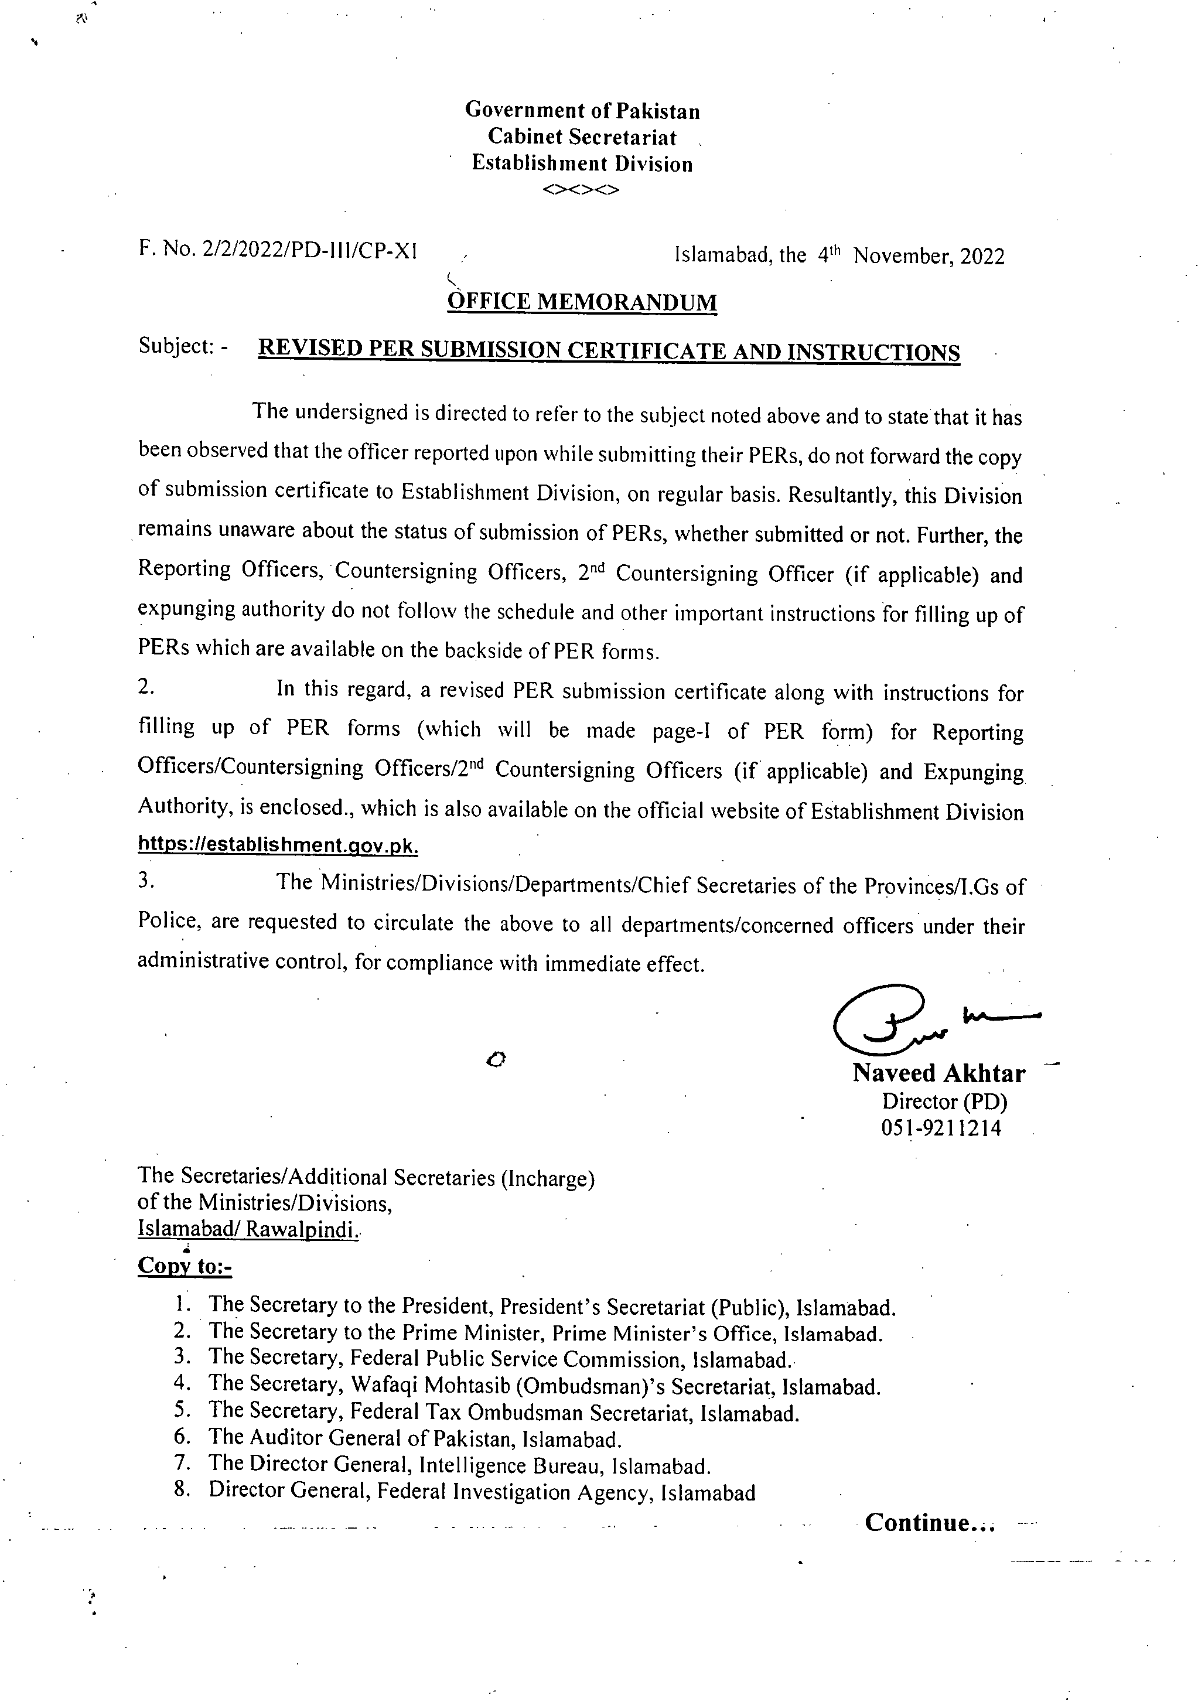
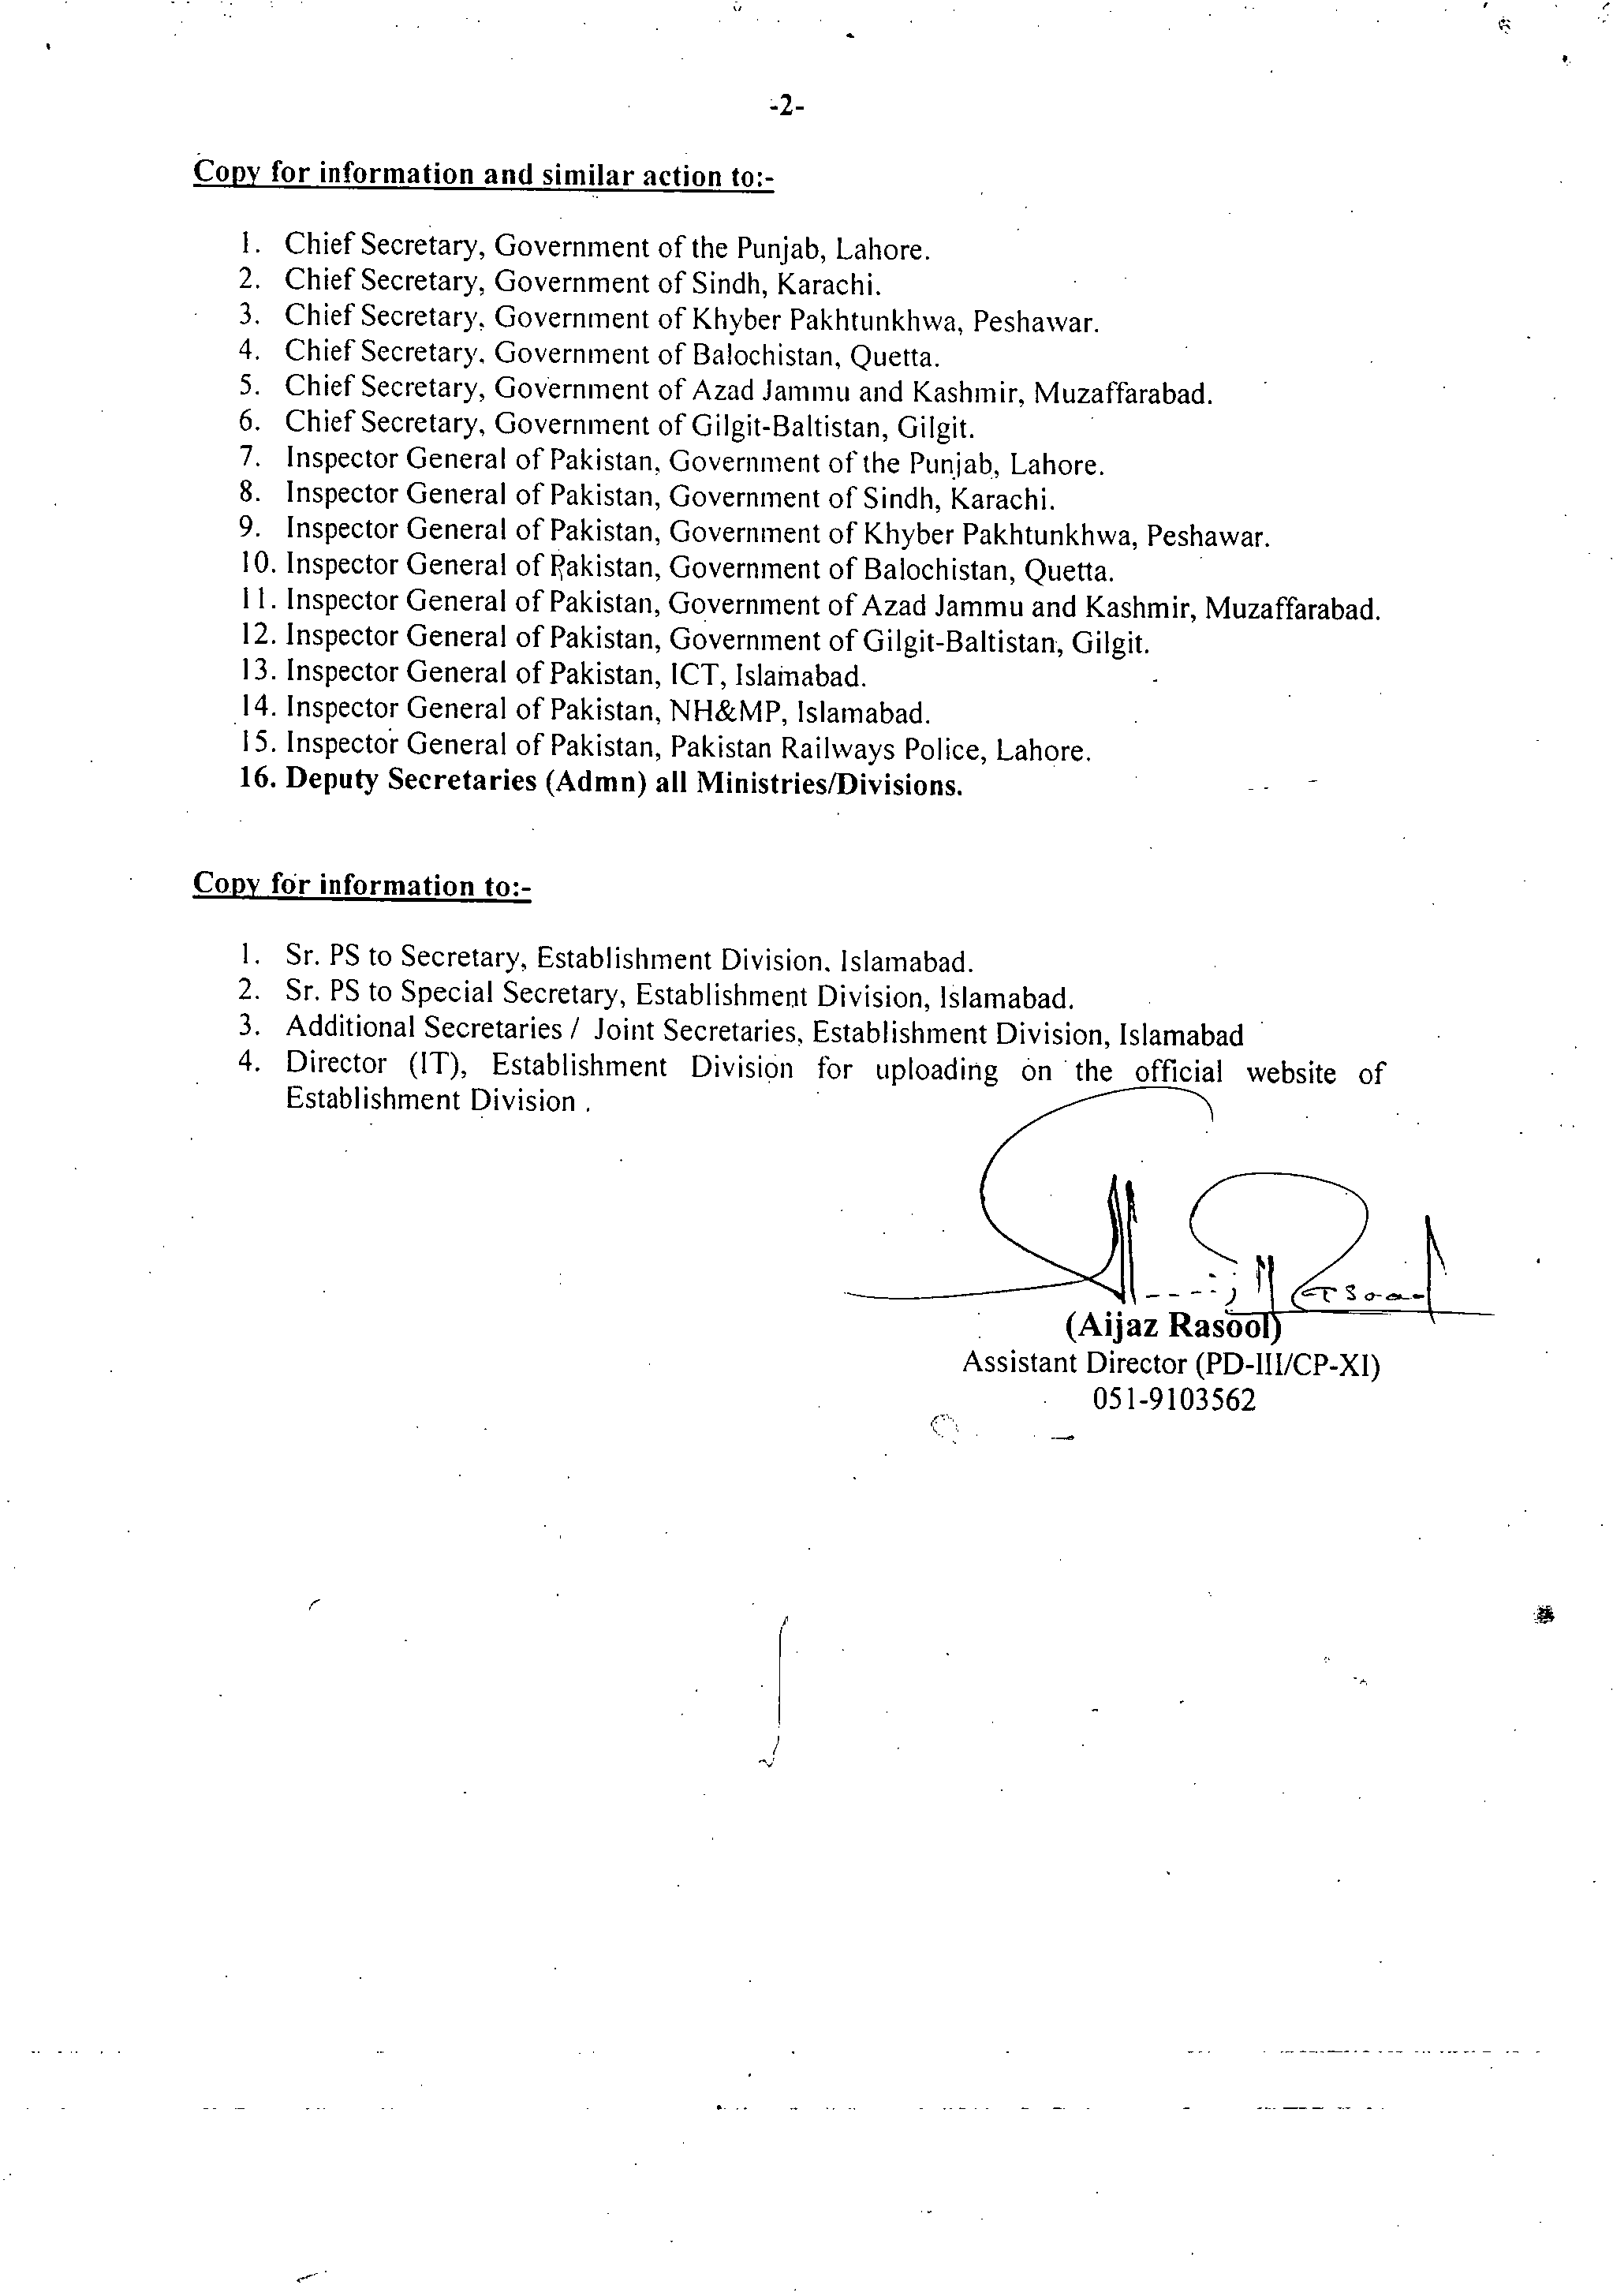
PER SUBMISSION CERTIFICATE FROM OFFICER REPORTED UPON

Certified that I ___________________________________________________________
(Name of Officer)
_______________________________________ have on ______________submitted my
(Designation/BS/Group/Service) (Date)

Performance Evaluation Report for the period from ______________________________

To be initiated by ________________________________________________________
(Name/Designation of Reporting Officer)

To be countersigned by ____________________________________________________
(Name/Designation of Countersigning Officer

Signatures ________________

To,

(Serving Administration
/Ministry/ Department) _________
__________________
__________________
CC :
Director (PD),
Establishment Division

Instructions for Officer Reported Upon.

Extract of Para-6.7 of AGPE-2004 and Guideline for filling up of PER

  - PER along with Submission Certificate should be prepared annually at the close of each calendar year which is required to be dispatched to the Officer Incharge entrusted with the maintenance of his/her C.R dossier and copy of above certificate must also be forwarded to Establishment Division.
  - Part I and II of PER are required to be filled in duplicate/typed and signed by the officer reported upon.
IMPORTANCE OF PER IN CAREER PLANNING

The Performance Evaluation Report (PER) is an important document which should be completed by the stakeholders with utmost care in stipulated time period. It is required during the appointments as well as promotions have to be made.

Instructions for Officer Reported Upon/Reporting Officer/Countersigning Officer/Second Countersigning Officer (if applicable) / Expunging Authority

Officer Report Upon PER along with Submission Certificate should be prepared annually at the close of each calendar year which is required to be dispatched to the Officer Incharge entrusted with the maintenance of his/her C.R dossier and copy of above certificate must also be forwarded to Establishment Division.Concerned Administration. After initiation/submission of above certificate along with set of PERs, the concerned administration will on the same date forward the same to Reporting Officer. This shall enable to ensure follow-up and prompt retrieval of PERs from the Reporting/Countersigning Officers.R.O/CO/2nd C.O (if applicable)After receiving PERs from administration, R.O will complete the same within two weeks. After that C.O will countersign in the next two weeks and 2nd Countersigned (if applicable) in subsequent two weeks and must follow the guidelines mentioned in backside of PER form.Expunging Authority in case of adverse remarksThe role of expunging authority is as a judge who examine/decide the representation of the officer reported upon and comments of the C.O on the representation under paras-3.40,3.41 and instructions provided on the backside of PER form of AGPE-2004.The concerned administration will get the PER completed and must be forward to Establishment Division under para-2.37 & 2.38 of AGPE-2004 as per given schedule
Officers of Grade 21 and 20 ..............................31st January

Officers of Grade 19 ..........................................28th February

Officers of Grade 18 and 17 ..............................31st March

Failing which disciplinary proceedings will be initiated under para-2.35 (iii) & (iv) of AGPE-2004 which is as under:-

(iii)The President is pleased to direct that the reporting officers concerned will be held responsible for ensuring that the reports of the officers working under them are written in time and sent to the Establishment Division/Administrative Ministry concerned when due with the least delay.

(iv)In case the President received further complaints in this regard, serious notice will be taken thereof and defaulting officers will be liable to disciplinary action.

-1-

1
FOR OFFICERS IN BPS 19 & 20 RESTRICTED


GOVERNMENT OF PAKISTAN


Ministry /Division/ Service/Group
Department/Office


PERFORMANCE EVALUATION REPORT


FOR THE PERIOD 20 TO 20

PART I

(TO BE FILLED IN BY THE OFFICER REPORTED UPON)


- Name (in block letters)

- Personnel number

- Date of birth

4. Date of entry in service

5. Post held during the period (with BPS)

- Academic qualifications

- Knowledge of languages (Please indicate proficiency in speaking (S), reading (R) and writing (W)


8. Training received during the evaluation period (Training courses attended earlier,
if any, may please be listed separately on the back page of the report).

2
Name of course attended   | Duration with dates   | Name of institution and country  
9. Period served

(i) In present post (ii) Under the reporting officer
 | 
PART II
(TO BE FILLED IN BY THE OFFICER REPORTED UPON)

1. Job description


3
2. Brief account of achievements during the period supported by statistical data where possible. Targets given and actual performance against such targets should be highlighted. Reasons for shortfall, if any, may also be stated.

PART III - 
(EVALUATION BY THE REPORTING OFFICER)


- Please comment on the officer's performance on the job as given in Part II (2) with special reference to his knowledge of work, ability to plan, organize and supervise, analytical skills, competence to take decisions and quality and quantity of output. How far was the officer able to achieve the targets? Comment on the officer's contribution, with the help of statistical data, if any, in the overall performance of the organization. Do you agree with what has been stated in Part II (2)?
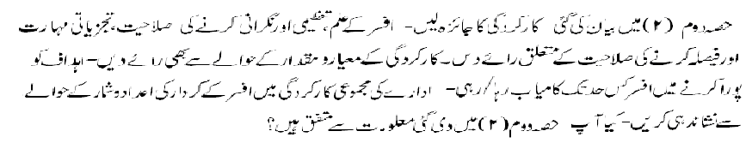

 |  | A | B | C | D
1 | Quality of work  Always produce work of exceptionally high Quality   |  |  |  |  | Generally produces work of poor quality.  
2 | Output of work  Always up-to-date; accumulates no arrears   |  |  |  |  | Always behind schedule; very slow disposal.  

4
2. Integrity (Morality, uprightness and honesty)

 |  | A | B | C | D
1. | Integrity  - General  Irreproachable |  |  |  |  | Unscrupulous  
1. | - Intellectual  Honest & straightforward |  |  |  |  | Devious; Sycophant  

3. Pen picture including the officer's strengths and weaknesses with focus on emotional stability, ability to work under pressure, communication skills and interpersonal effectiveness. (Weakness will not be considered as adverse entry unless intended to be treated as adverse). 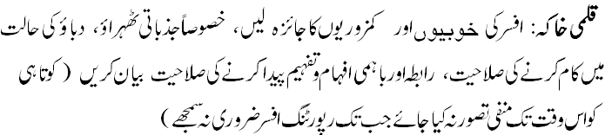

4. Area and level of professional expertise with suggessions for future posting.


5
5. Training and development needs.


6. Overall grading


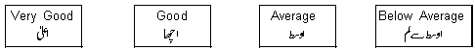

7. Fitness for promotion Comment on the officer's potential for holding a higher
 position and additional responsibilities.

Name of the reporting officer Signature
(Capital letters)


Designation Date

6
PART IV

(REMARKS OF THE COUNTERSIGNING OFFICER)


1. How often have you seen the work of the officer reported upon?


Very frequently   | Frequently   | Rarely   | Never  

2. How well do you know the officer? If you disagree with the assessment of
the reporting officer, please give reasons.

3. Overall grading

4. Recommendation for promotion (Comment on the officer's potential for holding a
 higher position and additional responsibilities).

7
5. Evaluation of the quality of assessment made by the reporting officer.

Exaggerated   |  | Fair   |  | Biased  

Name of the countersigning officer Signature
(Capital letters)


Designation Date

PART V

REMARKS OF THE SECOND COUNTERSIGNING OFFICER (IF ANY)


Name Signature


Designation Date

8
GUIDELINES FOR FILLING UP THE PER
- After initiation of their PER, the officers under report should immediately fill up the detachable ‘certificate’ giving names of the RO/CO and forward the same to the Officer Incharge of their respective confidential records. This exercise will ensure proper follow-up of the pending performance evaluation reports by the concerned Ministry/Division/Provincial Government etc.
- Forms should be filled in duplicate. Parts I and II are to be filled by the officer under report and should be typed. Part III will be filled by the Reporting Officer while the Countersigning/Second Countersigning Officers will fill Parts IV and V respectively.
- Each Division, Department, autonomous body and office etc. is required to prepare specific job descriptions giving main duties of each job to be mentioned in Part-II (1). The job descriptions may be finalized with the approval of the Head of the Organization or any person authorized by him.
- The officer under report should fill Part II (2) of the form as objectively as possible and short term and long term targets should be determined/ assigned with utmost care. The targets for each job may be formulated at the beginning of the year wherever possible. In other cases, the work performed during the year needs to be specifically mentioned.
- Assessment by the Reporting Officers should be job-specific and confined to the work done by the officer during the period under report. They should avoid giving a biased or evasive assessment of the officer under report, as the Countersigning Officers would be required to comment on the quality of the assessment made by them.
- The Reporting Officers should carryout their assessment in Part III through comments against each characteristic. Their opinions should represent the result of careful consideration and objective assessment so that, if called upon, they could justify the remarks/ comments. They may maintain a record of the work done by the subordinates in this regard.
- The Reporting Officers should be careful in giving the overall and comparative gradings. Special care should be taken so that no officer is placed at an undue disadvantage.
- The Countersigning Officers should weigh the remarks of the RO against their personal knowledge of the officer under report, compare him with other officers of the same grade working under different Reporting Officers, but under the same Countersigning Officer, and then give their overall assessment of the officer. In case of disagreement with the assessment done by the Reporting Officer, specific reasons should be recorded by the Countersigning Officers in Part IV (2).
- The Countersigning Officers should make an unbiased evaluation of the quality of performance evaluation made by the RO by categorizing the reports as exaggerated, fair or biased. This would evoke a greater sense of responsibility from the reporting officers.
- The Countersigning Officers should underline, in red ink, remarks which in their opinion are adverse and should be communicated to the officer reported upon. All adverse remarks whether remediable ore irremediable should be communicated to the officer under report, with a copy of communication placed in the CR dossier. Reporting Officers should ensure that they properly counsel the officer under report before adverse remarks are recorded.
- The Reporting and Countersigning Officers should be clear, direct, objective and unambiguous in their remarks. Vague impressions based on inadequate knowledge or isolated incidents should be avoided.
- Reports should be consistent with the pen picture, overall grading and comparative grading.

IMPORTANT
- Parts I and II of the PER should be duly filled and dispatched to the Reporting Officer not later than the 15th of January. The ROs should forward the report to the Countersigning Officer within two weeks of receipt after giving their views in Parts III. The COs should the finalize their comments in Part IV within two weeks of receipt of PER. The Second Countersigning Officers, if any, should also complete their assessment within a period of two weeks.
- Name and designation of Reporting /Countersigning Officers should be clearly written. Comments should be legible and in the prescribed format and which can be easily scanned.
- Personnel Number is to be filled in by the officer under report, if allotted.
- Proforma has been devised in English/Urdu to provide flexibility to RO/CO in the choice of language.
- Comparative grading only applies to officers falling in very good, good and average categories. This grading would not apply to anyone falling in below average category in Part III (6).

