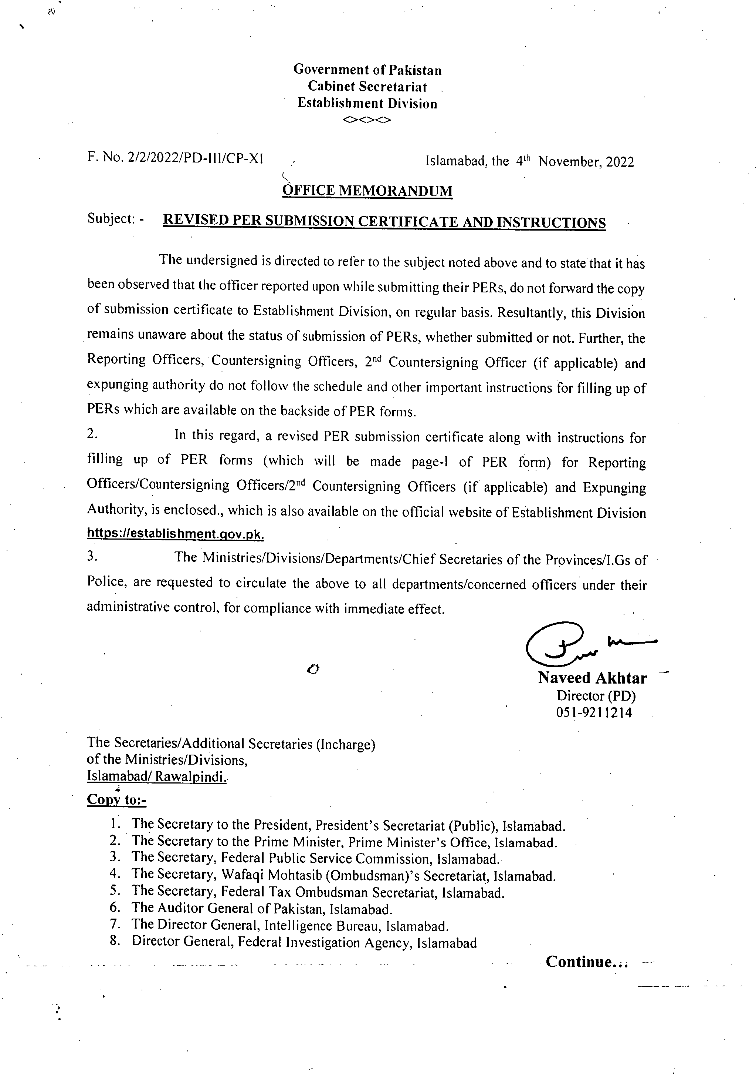
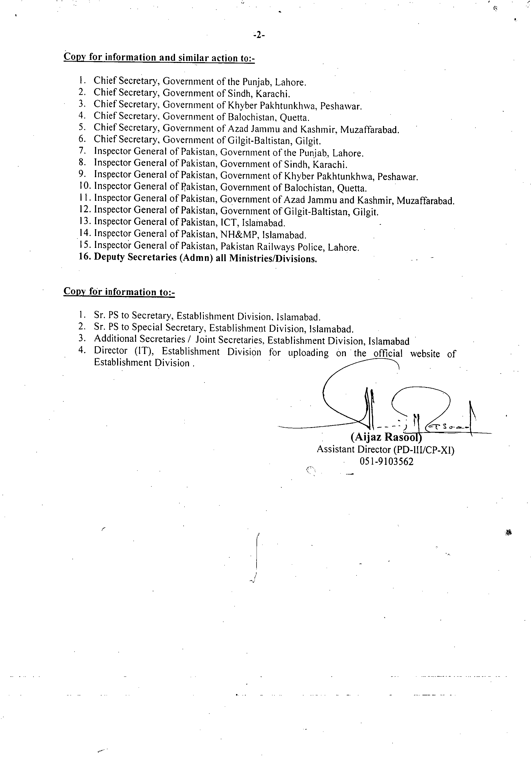
PER SUBMISSION CERTIFICATE FROM OFFICER REPORTED UPON

Certified that I ___________________________________________________________
(Name of Officer)
_______________________________________ have on ______________submitted my
(Designation/BS/Group/Service) (Date)

Performance Evaluation Report for the period from ______________________________

To be initiated by ________________________________________________________
(Name/Designation of Reporting Officer)

To be countersigned by ____________________________________________________
(Name/Designation of Countersigning Officer

Signatures ________________

To,

(Serving Administration
/Ministry/ Department) _________
__________________
__________________
CC :
Director (PD),
Establishment Division

Instructions for Officer Reported Upon.

Extract of Para-6.7 of AGPE-2004 and Guideline for filling up of PER

  - PER along with Submission Certificate should be prepared annually at the close of each calendar year which is required to be dispatched to the Officer Incharge entrusted with the maintenance of his/her C.R dossier and copy of above certificate must also be forwarded to Establishment Division.
  - Part I and II of PER are required to be filled in duplicate/typed and signed by the officer reported upon.
IMPORTANCE OF PER IN CAREER PLANNING

The Performance Evaluation Report (PER) is an important document which should be completed by the stakeholders with utmost care in stipulated time period. It is required during the appointments as well as promotions have to be made.

Instructions for Officer Reported Upon/Reporting Officer/Countersigning Officer/Second Countersigning Officer (if applicable) / Expunging Authority

Officer Report Upon PER along with Submission Certificate should be prepared annually at the close of each calendar year which is required to be dispatched to the Officer Incharge entrusted with the maintenance of his/her C.R dossier and copy of above certificate must also be forwarded to Establishment Division.Concerned Administration. After initiation/submission of above certificate along with set of PERs, the concerned administration will on the same date forward the same to Reporting Officer. This shall enable to ensure follow-up and prompt retrieval of PERs from the Reporting/Countersigning Officers.R.O/CO/2nd C.O (if applicable)After receiving PERs from administration, R.O will complete the same within two weeks. After that C.O will countersign in the next two weeks and 2nd Countersigned (if applicable) in subsequent two weeks and must follow the guidelines mentioned in backside of PER form.Expunging Authority in case of adverse remarksThe role of expunging authority is as a judge who examine/decide the representation of the officer reported upon and comments of the C.O on the representation under paras-3.40,3.41 and instructions provided on the backside of PER form of AGPE-2004.The concerned administration will get the PER completed and must be forward to Establishment Division under para-2.37 & 2.38 of AGPE-2004 as per given schedule
Officers of Grade 21 and 20 ..............................31st January

Officers of Grade 19 ..........................................28th February

Officers of Grade 18 and 17 ..............................31st March

Failing which disciplinary proceedings will be initiated under para-2.35 (iii) & (iv) of AGPE-2004 which is as under:-

(iii)The President is pleased to direct that the reporting officers concerned will be held responsible for ensuring that the reports of the officers working under them are written in time and sent to the Establishment Division/Administrative Ministry concerned when due with the least delay.

(iv)In case the President received further complaints in this regard, serious notice will be taken thereof and defaulting officers will be liable to disciplinary action.

-1-

1
FOR OFFICERS IN BPS 17 & 18 RESTRICTED


GOVERNMENT OF PAKISTAN


Ministry /Division/ Service/Group

Department/Office


PERFORMANCE EVALUATION REPORT


FOR THE PERIOD 20 TO 20

PART I

(TO BE FILLED IN BY THE OFFICER REPORTED UPON)


- Name (in block letters)

- Personnel number

- Date of birth

4. Date of entry in service

5. Post held during the period (with BPS)

- Academic qualifications

- Knowledge of languages (Please indicate proficiency in speaking (S), reading (R) and writing (W)


2

8. Training received during the evaluation period


Name of course attended   | Duration with dates   | Name of institution and country  
9. Period served

(i) In present post (ii) Under the reporting officer
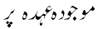 | 
PART II
(TO BE FILLED IN BY THE OFFICER REPORTED UPON)

1. Job description


3

2. Brief account of performance on the job during the period supported by statistical data
where possible. Targets given and actual performance against such targets should be
highlighted. Reasons fro shortfall, if any, may also be stated.
PART III - 
(EVALUATION BY THE REPORTING OFFICER)

The rating in Part III should be recorded by initialing the appropriate box.
The ratings denoted by alphabets are as follows:
'A' Very Good, 'B' Good, 'C' Average, 'D' Below Average

For uniform interpretation of qualities, two extreme shades are mentioned
against each quality.
4
 |  | A | B | C | D
1. | Intelligence    Exceptionally bright; excellent comprehension   |  |  |  |  | Dull; slow  
 |  | A | B | C | D
2. | Confidence and will power    Exceptionally confident and resolute   |  |  |  |  | Uncertain; hesitant  
3. | Acceptance of responsibility    Always prepared to take on responsibility even in difficult cases.   |  |  |  |  | Reluctant to take on responsibility; will avoid it whenever possible.  
4. | Reliability under pressure    Calm and exceptionally reliable at all times -  |  |  |  |  | Confused and easily flustered even under normal pressure.  
5. | Financial responsibility    Exercises due care and discipline   |  |  |  |  | Irresponsible  
6. | Relations with -   (i) Superiors -   Cooperative and trusted   |  |  |  |  | Un-cooperative  
6. | ii) Colleagues    Works well in a team   |  |  |  |  | Difficult colleague  
6. | iii) Subordinates -   Courteous and effective;  encouraging   |  |  |  |  | Discourteous and intolerant;  
7. | Behavior with public    Courteous and helpful -  |  |  |  |  | Arrogant, discourteous and indifferent  
8. | Ability to decide routine matters  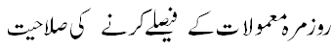  Logical and decisive -  | 5 |  |  |  | Indecisive;  Vacillating  
 |  | A | B | C | D
9. | Knowledge of relevant laws, rules, regulations, instructions and procedures.  Exceptionally well informed,  keeps abreast of latest developments.   |  |  |  |  | Ignorant and  Uninformed.  

PART IV - 
(REPORTING OFFICER'S EVALUATION)
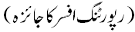

1. Please comment on the officer's performance on the job as given in Part II(2)
with special reference to knowledge of work, quality and quantity of output.
How far was the officer able to achieve targets? Do you agree with what has
been stated in Part II (2)?
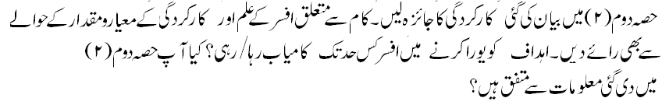

 |  | A | B | C | D
1 | Quality of work  Always produce work of exceptionally high Quality   |  |  |  |  | Generally produces work of poor quality.  
2 | Output of work  Always up-to-date; accumulates no arrears   |  |  |  |  | Always behind schedule; very slow disposal.  

6

2. Integrity (Morality, uprightness and honesty) -

 |  | A | B | C | D
1. | Integrity  - General  Irreproachable |  |  |  |  | Unscrupulous  
1. | - Intellectual  Honest & straightforward |  |  |  |  | Devious; Sycophant  

3. Pen picture with focus on the officer's strengths and weaknesses not
covered in Part III (Weakness will not be considered as adverse entries unless
intended to be treated as adverse).


4. Special aptitude


5. Recommendations for future training


7
6. Overall grading


 |  | Reporting officer   | Countersigning officer  
(i) | Very Good  
(ii) | Good  
(iii) | Average  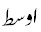
(iv) | Below Average  

7. Fitness for promotion


 |  | Reporting officer | Countersigning officer
(i) | Fit for promotion  
(ii) | Recently promoted/appointed.  Assessment premature  
(iii) | Not yet fit for promotion  
(iv) | Unlikely to progress further  

Name of the reporting officer Signature
(Capital letters)


Designation Date


8
PART V

(REMARKS OF THE COUNTERSIGNING OFFICER)

1. How well do you know the officer? If you disagree with the assessment of
the reporting officer, please give reasons


- Evaluation of the quality of assessment made by the reporting officer

Exaggerated   |  | Fair   |  | Biased  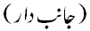

Name of the countersigning officer Signature
(Capital letters)


Designation Date

9
PART VI

REMARKS OF THE SECOND COUNTERSIGNING OFFICER (IF ANY)


Name Signature


Designation Date

10

